

**Functional Design Document for Financial Dimensions on the PR header.**

***FDD – Financial dimensions to be given on the purchase requisition header.***

Prepared for

**DaxArch Solutions**

Project

**PharmEasy**

Prepared by

Utthej

Contributors

Date: 2023-03-24

Version: 1.0

**Revision and Signoff Sheet**

**FDD Record**

|  |  |  |  |
| --- | --- | --- | --- |
| **Date** | **Author** | **Version** | **Change reference** |
| 2023-03-24 | Utthej | 1.0 |  |
|  |  |  |  |
|  |  |  |  |

**Client Review and Approval**

|  |  |  |  |
| --- | --- | --- | --- |
| **Name** | **Version approved** | **Position** | **Date** |
| Kishore, Jaipal |  |  |  |
|  |  |  |  |
|  |  |  |  |

Table of Contents

Table of Contents 3

1 Introduction 4

Background 4

Purpose 4

Audience / Stakeholders 4

2 Justification 5

Business Requirement 5

Standard Microsoft Dynamics 5

Purpose / Justification for the Modification 5

Open Issues/ Actions 5

3 Modification Description 6

Design Related Assumptions 6

Modifications to Forms / Screens 6

4 Test cases 9

Business Process Flows 9

6 Role based Security Implementation 11

Security Implementation for new objects 11

1. Introduction

## Background

When the Purchase requisition is created there are no financial dimensions.

## Purpose

User required the financial dimension on the header level of the PR.

## Audience / Stakeholders

This document is intended for the core team members of project team

* Kishore, Jaipal

1. Justification

## Business Requirement

The functionality is that the financial dimensions are to be created manually while creating the purchase requestion and that similar dimensions are to be projected in the line level of the PR.

## Standard Microsoft Dynamics

There is no standard functionality available for that specific condition.

## Purpose / Justification for the Modification

This process will help to see the financial dimensions at the header level as well as the line level in the PR

## Open Issues/ Actions

No open Issues/Actions

|  |  |  |  |
| --- | --- | --- | --- |
| **Issue/Action ID** | **Description** | **Assigned to** | **Deadline** |
|  | The functionality is that the financial dimensions are to be created manually while creating the purchase requestion and that similar dimensions are to be projected in the line level of the PR. |  |  |

1. Modification Description

***Business Process Flows***

## Design Related Assumptions

1. User will navigate to the assigned path.

## Modifications to Forms / Screens

**Procurement and Sourcing> Purchase requestion > All Purchase requestion.**

1. The user has to create the new PR.
2. Further morehas to add the financial dimensions manually as shown below.

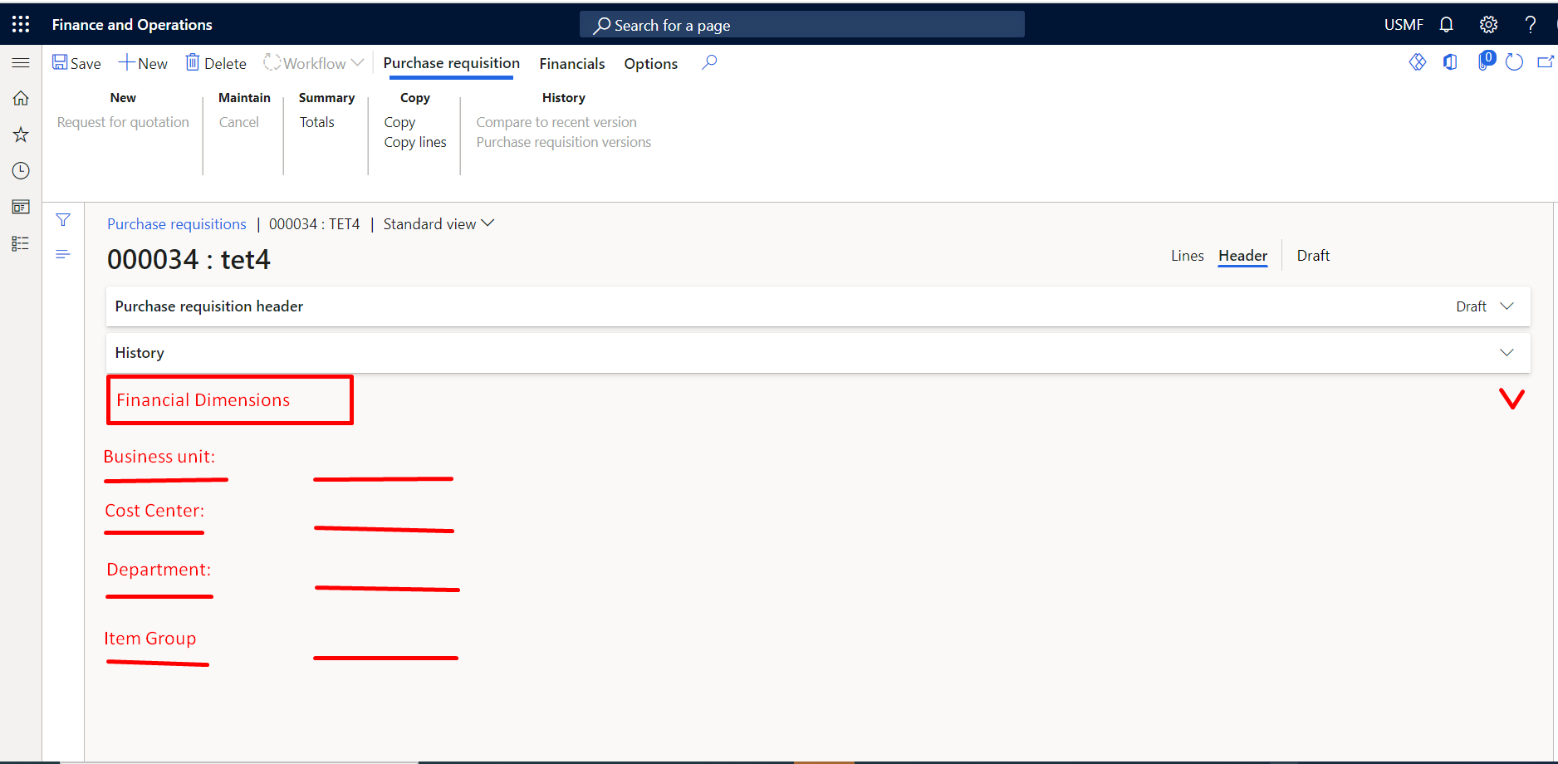

1. The Purchase requestation header now has the financial diemsions which are entered manually.
2. Now, the user adds the line in the line level.
3. As soon as the line is entered the financial dimensions which are given in the header level should also be projected in the line level.

**NOTE:**

1. The item which previously has the financial dimensions in the item level should be over- ridden if there has the same dimension combination for that particular dimension.

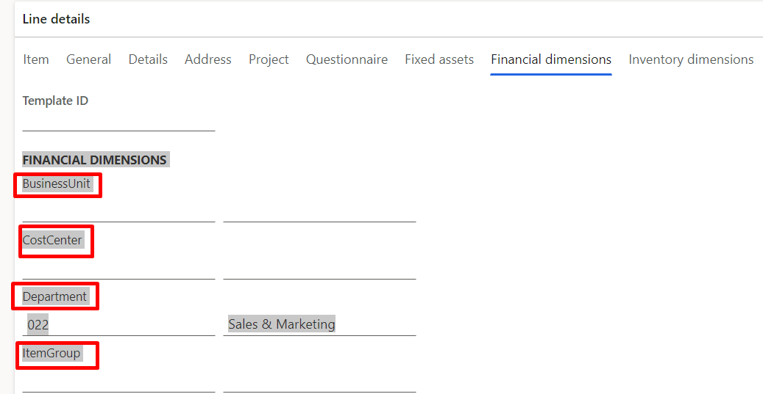

1. After creation of the multiple lines in the PR if the user changes the financial diemnsion in the line level that should not be changed in the header level in the PR.
2. If the user changes the Financial dimensions before confirming the PR in the header level. Then the Financial dimensions should change by throwing the below screen.

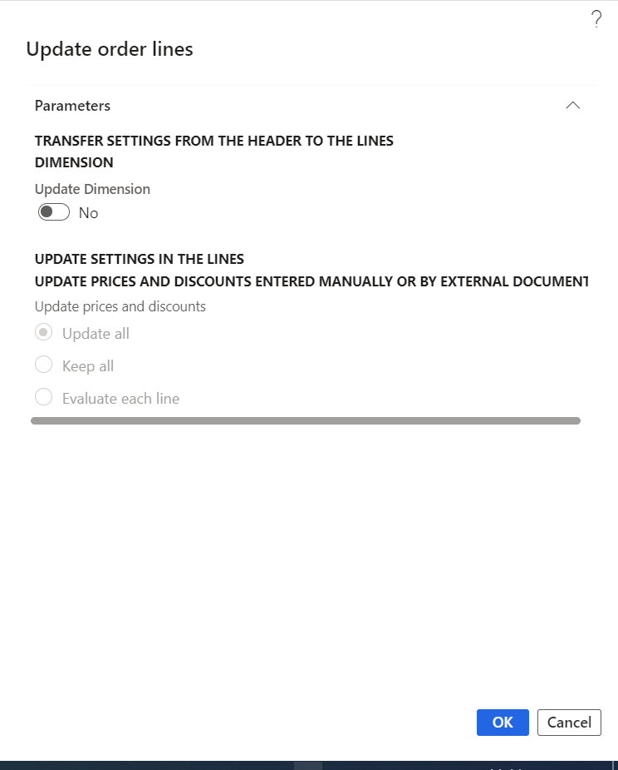

1. Test cases

## Business Process Flows

# **6 Role based Security Implementation**

## Security Implementation for new objects

**NOTE –**

|  |  |  |  |  |
| --- | --- | --- | --- | --- |
| Object Added (Table/Form/  Report/Class details) | Linked Menu Item to Access the Object | Privilege Linked to the Menu Item | Permissions required if no linked menu item or privilege | Comments on functional requirement on Security for this object |
|  |  |  |  |  |